

Student Handbook
Bridge Education (AP) Ltd
Building bridges within education.
Based in March, Cambridge and online. All correspondence welcome.
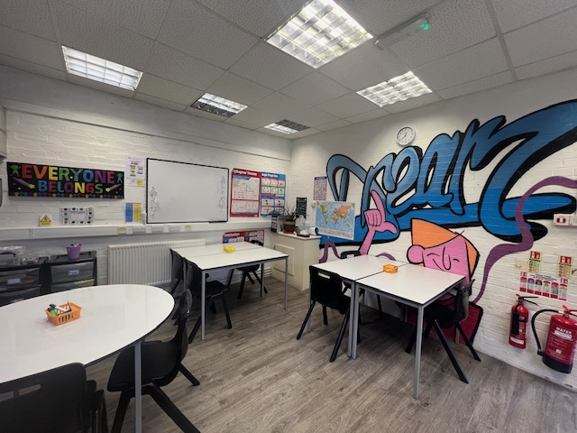
Email: admin@bridgeeducationap.co.uk
Phone: 01354 657014 or 07535 88776
About Bridge Education (AP) Ltd
Bridge Education (AP) Ltd is a registered alternative provision providing up to 15 hours education and therapeutic sessions per week per student for many different reasons. This could be a school refuser, a mental health issue, exclusion from mainstream, those students waiting for a school place or in care of the local authority.
We are fully insured and registered with Cambridgeshire County Council as an alternative provision. All our staff are enhanced DBS checked and have completed Safeguarding and Prevent training.
We are currently going through the process of applying to become a registered exam centre for AQA and Pearson Edexcel, ready for the exams of 2025.
Students will have access to online learning programs both within our centres and at home. These contain KS1-KS4 English Language, English Literature, Maths, Science, Geography and KS5 Science. There are GCSE level access and Functional Skills, Entry 1 to level 2 along with access to complete AQA unit awards.

Meet The Team

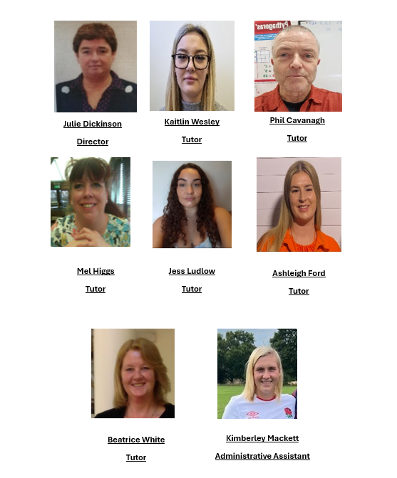

Term and Holiday Dates 2024-2025

Autumn term 2024

Staff/planning meeting - Wednesday 4th September 2024
Students return - Thursday 5th September 2024
Half term break - Friday 25th October 2024
Students return - Monday 4th November 2024
Half term break - Friday 20th December 2024

Spring term 2025

Students return - Monday 6th January 2025
Half term break - Friday 14th February 2025
Students return - Monday 24th February 2025
Half term break - Friday 4th April 2025

Summer term 2025

Students return - Tuesday 22nd April 2025
Half term break - Friday 23rd May 2025
Students return - Monday 2nd June 2025
Half term break - Friday 18th July 2025

Behaviour Policy
Vision
The Vision of Bridge Education (AP) is to provide a safe learning environment where everyone can achieve the best of their ability. To be able to succeed, grow in self-confidence and be proud.
Our Values are:
We value an education that nurtures a passion for learning that will last a lifetime through the context of human relationships and a foundational knowledge base. We value an education that cultivates virtuous character including excellence with honour, moral courage, compassion and relational grace.

Roles and Responsibilities of Staff
All staff have high expectations of our pupils regarding their behaviour, and they strive to ensure that all pupils work to the best of their ability.
It is the responsibility of staff to ensure that the aims and expectations of this policy are upheld in their classes.
The teams work together to ensure that consistent and positive approaches are in place to support the pupils.

The purpose of this consistent approach is to identify concerns and antecedents to develop targets and positive support strategies that lead to positive behaviour. Parents /carers and the pupils will be involved in this process where appropriate.
Roles and Responsibilities of Parents and Carers
We are committed to involve parents and carers in all aspects of their child’s education including positive behaviour support. External support may be provided to help parents and carers respond to behaviour that may challenge in the home environment.

Bullying
Staff promote a no-bullying approach through:
• Being punctual for sessions with Pupils and being highly observant
• Promoting self-discipline and good behaviour
• Providing a positive role model in line with Bridge Education (AP) expectations
• Praising co-operative and non-confrontational behaviour
• Responding to and following up all incidents consistently
• Offering the victim immediate support
• Ensuring that all repeated or serious incidents of bullying are reported to the Head teacher
• Helping both the victims of bullying and the bullies themselves raise their self-esteem through activities that are designed to improve their standing
• Discussing bullying in PSHE sessions, where group discussion is possible
• Promoting relationships and opportunities for pupils to share concerns with adults

Safeguarding
Our safeguarding team here at Bridge Education (AP) is Julie. She has extensive experience in supporting students and families with a wide range of concerns. If anything is worrying you, please do not hesitate to contact the team by emailing: jandl@bridgeeducationap.co.uk

Typical Day
A typical day here at Bridge Education will usually involve staff collecting you from your home address and bringing you into the Centre. Sometimes you will arrive to the Centre by taxi where staff will be waiting. How you arrive to the Centre will be determined by your referrer.
You will be offered refreshments throughout your session and will be taught a range of subjects that meet curriculum requirements. Core subjects include Maths, English Language, English Literature, Biology, Chemistry, Physics and PSHE. You may on request cover subjects such as Geography, History and Art. These subjects will be adapted to meet your needs and ability to help deliver a personalised learning programme.
Sessions usually run 09.00-12.00 and 12.00-15.00 and can take place at either one of our Centres. You will be told which Centre you will be attending prior to starting. These Centres are based at:
- Robingoodfellows Lane, March, Cambridgeshire, PE15 8HL
- Unit 1C, Gateway, Bar Hill, Cambridge, CB23 8SQ.
Sometimes at the end of term you will be rewarded an activity which can include visiting the park, bowling, swimming or mini golf. Whether you get to attend the reward activity will be dependent on your attendance, engagement and behaviour for the term.
During your session you will have opportunities to meet new people and develop new friendships. We actively encourage social skill activities towards the end of each session, should all work have been completed.
Staff will then return you back home or a taxi will collect you from the Centre should this be the referrers preferred transport option.

